NAME:VENKATRAMAMOORTHY.G
- Show synchronous vs asynchronous execution.
Code:
console.log('hi')
console.log('bye')
console.log('hello');
setTimeout(()=>{
console.log("5 second");
},5000);
OUTPUT:
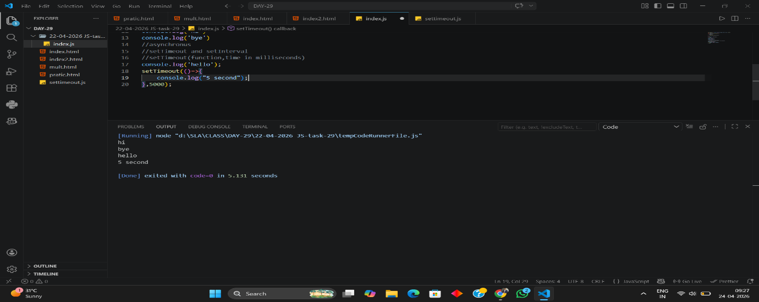
- Print a message after 2 seconds.
CODE:
setTimeout(()=>console.log('printing after 2 sec'),2000);
OUTPUT:
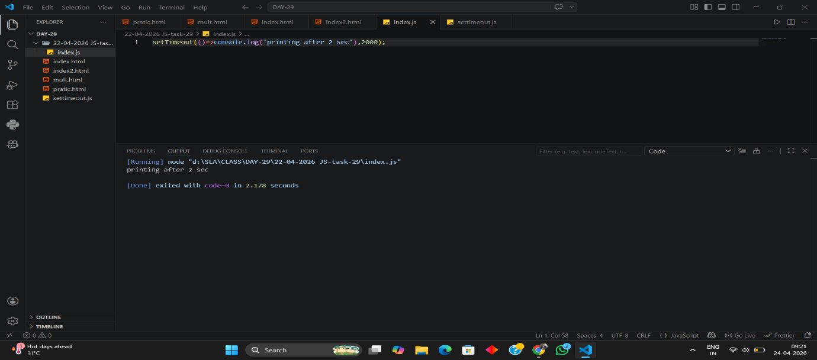
- Print a counter every 1 second.
CODE:
let count=0;
let interval=setInterval(()=>
{count++;
if(count>5){
clearInterval(interval);
}
else{
console.log(count);
}},1000)
OUTPUT:
